1/2/20 **MAVEN**

Maven is a project management tool/build automation tool used for building java projects. It describes the dependencies and downloads those dependencies (java libraries) from the repositories such as maven central repository and stores them in the local cache.

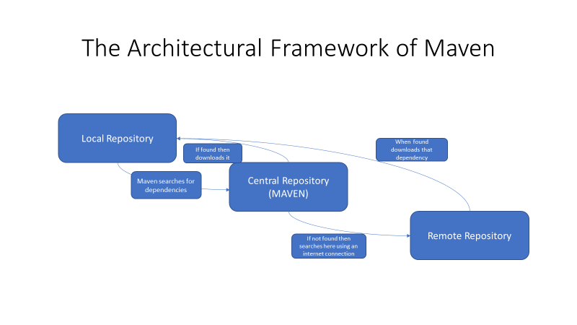

A main component of maven is the pom.xml file. It is the file that contains all the dependencies that are required to be downloaded to help run the program. Therefore, maven searches each of the dependencies in the central repository first. If the dependency is present, then it will download it into the local repository. If the dependency is not present, then maven searches in the remote repository via internet connection and then downloads it into the local repository.

**Advantages :**

1. Makes the project building process easy.
2. Rather then manually downloading the dependencies after every programming language update, maven automatically downloads the requires dependencies mentioned in the pom.xml file.